Mice in my kitchen
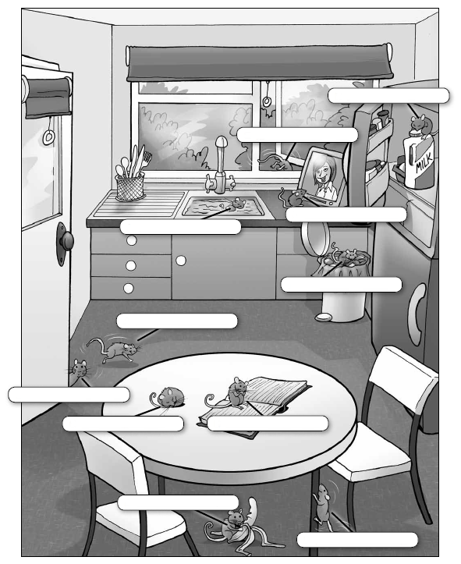

Activity 1→ Complete the text using the verbs in brackets in the present continuous. (be + verb + ing)
There are eleven mice in my kitchen. Their names are Bubble, Squeak, Cheese, Pickle, Pinch, Scoff, Scruff, Nibble, Scurry, Scratch and Sniff. What are the mice doing? Bubble (sleep) _____________________ and Squeak (read) ______________________ a book. Cheese (drink) ___________________ milk in the fridge and Pickle (eat) ______________ a banana under the table. Pinch (rush) ____________________ into the room and Scoff (jump) ___________________ out of the window. Scruff (sit) __________________ in the bin and Nibble (run) ______________________ up a table leg. Scratch (watch) ___________________ TV. Sniff (have) _________________________ a bath in the sink! But where is Scurry?
Activity 2 → Look at the illustration, read the text again and write the names of the mice in the correct boxes.

