PRESENT CONTINUOUS
1. WRITE. WHAT ARE THE PEOPLE DOING?
NAPIŠ, CO DĚLAJÍ LIDÉ NA OBRÁZKU.
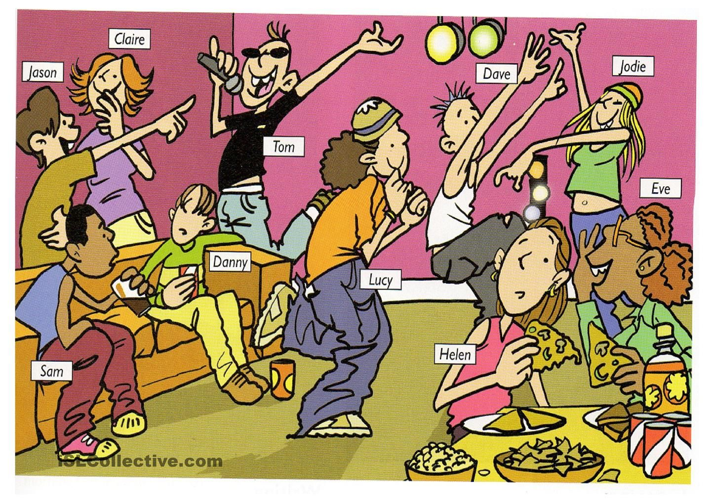
EAT – DRINK – SPEAK – LAUGH – SING – DANCE - LISTEN
Ex. Danny is sitting. __________________________________________________________________
_______________________________________________________________________________________________
_______________________________________________________________________________________________
_______________________________________________________________________________________________
_______________________________________________________________________________________________
_______________________________________________________________________________________________
_______________________________________________________________________________________________
_______________________________________________________________________________________________

2. TRUE OR FALSE? IF FALSE, CORRECT THE SENTENCE.
PRAVDA NEBO NE? POKUD NE, OPRAV VĚTU.
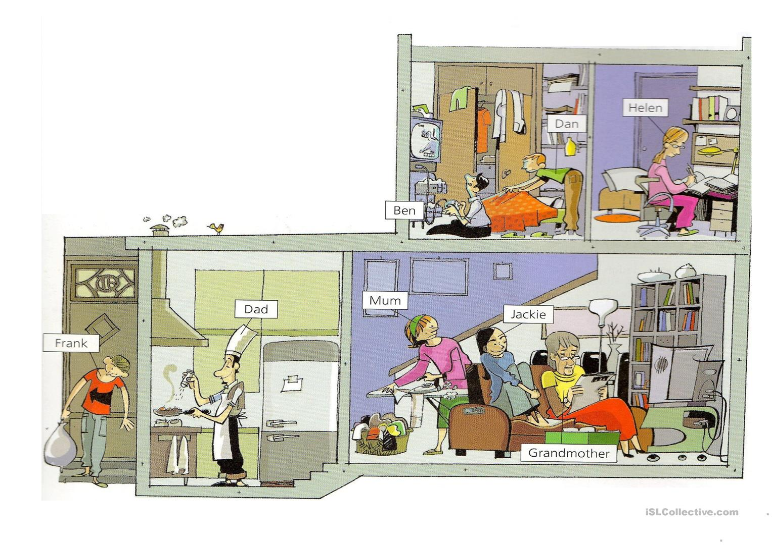
- FRANK IS TAKING OUT THE RUBBISH
- MUM IS COOKING
- JACKIE IS READING A BOOK
- GRANDMOTHER IS DOING HOMEWORK
- BEN IS PLAYING COMPUTER GAMES
- HELEN IS EATING

3. DRAW: WHAT ARE YOU DOING NOW?
NAKRESLI, CO TEĎ DĚLÁŠ.

