DESCRIBE THE PICTURE

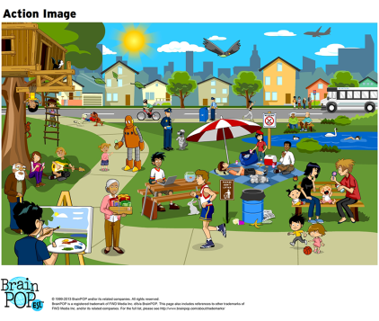

Example: The eagle is flying in the sky.

